Ex. No. 2 | HTML & CSS Forms
Date of Exercise | 03.08.2026
GitHub Host Link | https://praneettigga.github.io/web-tech-lab/
Aim
To design and develop a Student Registration Form using HTML5 form elements and the different input types (text, email, password, number, date, radio, checkbox, dropdown, datalist, range, color, etc.) with client-side validation attributes, and to style and lay out the form using internal CSS.
Description
The <form> element: The <form> element wraps all the controls of the registration form. It collects user input and, on submission, sends it to the server; the action and method attributes define where and how the data is sent.
Text-based inputs: <input type="text">, "email", "password", "tel", "url" and "search" accept different kinds of text. The browser validates email and url formats automatically, masks the password, and shows a suitable keyboard on mobile devices. The placeholder attribute gives a hint inside an empty field.
Numeric and date/time inputs: type="number" (with min and max), "date", "month" and "time" provide native pickers and restrict the values entered.
Choice controls: Radio buttons (type="radio") with the same name allow only one selection, whereas checkboxes (type="checkbox") allow multiple selections. The <select> and <option> elements create a dropdown list, and <input list> with <datalist> offers suggestions while still allowing free text.
Other input types: type="range" gives a slider for a value within min and max, type="color" opens a color picker, type="file" lets the user upload a file, and <textarea> accepts multi-line text such as the address.
Validation attributes: The required attribute prevents submission of an empty field, while min, max and type-based checks (email, url) validate the value entered.
Form layout: <table>, <tr> and <td> align each label with its input control, and <div> elements with the classes section-box and section-title group the fields into Personal Details, Academic Details and Additional Information.
Buttons: <button type="submit"> submits the form after validation is passed.
Internal CSS: A <style> block sets the font, background color, the centered container, borders, padding, input widths, headings and button spacing. Selectors used include element, class and attribute selectors such as input[type="text"].
Procedure:
1. Select the form to be designed: a Student Registration Form.
2. Create a folder Expt2 with a file form.html.
3. Begin form.html with the <!doctype html> declaration and add the <html>, <head> (with <title>) and <body> tags.
4. Write internal CSS inside <style> to set the page font and background, the container width and border, heading color, table, input, textarea, section-box and button styles.
5. Create a <div class="container"> in the body, add the <h2> heading "Student Registration Form" and open a <form> element.
6. Create the Personal Details section box with a table holding the Full Name, Register Number, Email, Password, Phone Number, Age, Date of Birth and Gender (radio buttons) fields, using required, placeholder, min and max attributes.
7. Create the Academic Details section box with Department and Year dropdowns (<select>), a Favorite Subject field using <input list> and <datalist>, and a Website (type="url") field.
8. Create the Additional Information section box with Skills (checkboxes), Resume (file), Search Course (search), Admission Month (month), Interview Time (time), Favorite Color (color), Skill Level (range), Address (<textarea>) and a required terms-and-conditions checkbox.
9. Add the Register button (type="submit") inside a centered <div class="buttons"> and close the form and the container.
10. Save the file, open it in a browser and verify the layout of every field.
11. Test the validation by submitting the form with empty required fields and with invalid email/number values, and then with valid data.
12. Push the code to GitHub and host it using GitHub Pages to obtain the deployment link.
Program
form.html
<!doctype html>
<html>
<head>
<title>Student Registration Form</title>

<style>
body {
font-family: Arial, sans-serif;
background: #f2f2f2;
}

.container {
width: 700px;
margin: 30px auto;
background: white;
padding: 20px;
border: 1px solid #ccc;
}

h2 {
text-align: center;
color: #003366;
}

table {
width: 100%;
}

td {
padding: 8px;
vertical-align: top;
}

input[type="text"],
input[type="email"],
input[type="password"],
input[type="number"],
input[type="date"],
input[type="tel"],
input[type="url"],
input[type="search"],
select,
textarea {
width: 95%;
padding: 6px;
border: 1px solid #999;
}

textarea {
resize: vertical;
}

.section-box {
margin-bottom: 20px;
border: 1px solid #bbb;
padding: 12px;
}

.section-title {
font-weight: bold;
margin-bottom: 10px;
color: #003366;
}

.buttons {
text-align: center;
}

button {
padding: 8px 18px;
margin: 5px;
}
</style>
</head>

<body>
<div class="container">
<h2>Student Registration Form</h2>

<form>
<div class="section-box">
<div class="section-title">Personal Details</div>

<table>
<tr>
<td>Full Name</td>
<td>
<input type="text" placeholder="Enter your name" required />
</td>
</tr>

<tr>
<td>Register Number</td>
<td><input type="text" placeholder="URK24CS0000" /></td>
</tr>

<tr>
<td>Email</td>
<td><input type="email" required /></td>
</tr>

<tr>
<td>Password</td>
<td><input type="password" required /></td>
</tr>

<tr>
<td>Phone Number</td>
<td><input type="tel" placeholder="9876543210" /></td>
</tr>

<tr>
<td>Age</td>
<td><input type="number" min="17" max="30" /></td>
</tr>

<tr>
<td>Date of Birth</td>
<td><input type="date" /></td>
</tr>

<tr>
<td>Gender</td>
<td>
<input type="radio" name="gender" /> Male
<input type="radio" name="gender" /> Female
<input type="radio" name="gender" /> Other
</td>
</tr>
</table>
</div>

<div class="section-box">
<div class="section-title">Academic Details</div>

<table>
<tr>
<td>Department</td>
<td>
<select>
<option>CSE</option>
<option>IT</option>
<option>ECE</option>
<option>EEE</option>
<option>AIML</option>
</select>
</td>
</tr>

<tr>
<td>Year</td>
<td>
<select>
<option>1st Year</option>
<option>2nd Year</option>
<option>3rd Year</option>
<option>4th Year</option>
</select>
</td>
</tr>

<tr>
<td>Favorite Subject</td>
<td>
<input list="subjects" />

<datalist id="subjects">
<option>Web Technology</option>
<option>DBMS</option>
<option>Operating Systems</option>
<option>Computer Networks</option>
<option>Java Programming</option>
</datalist>
</td>
</tr>

<tr>
<td>Website</td>
<td><input type="url" placeholder="https://example.com" /></td>
</tr>
</table>
</div>

<div class="section-box">
<div class="section-title">Additional Information</div>

<table>
<tr>
<td>Skills</td>
<td>
<input type="checkbox" /> HTML <input type="checkbox" /> CSS
<input type="checkbox" /> JavaScript
<input type="checkbox" /> Python
</td>
</tr>

<tr>
<td>Resume</td>
<td><input type="file" /></td>
</tr>

<tr>
<td>Search Course</td>
<td><input type="search" /></td>
</tr>

<tr>
<td>Admission Month</td>
<td><input type="month" /></td>
</tr>

<tr>
<td>Interview Time</td>
<td><input type="time" /></td>
</tr>

<tr>
<td>Favorite Color</td>
<td><input type="color" /></td>
</tr>

<tr>
<td>Skill Level</td>
<td><input type="range" min="1" max="10" /></td>
</tr>

<tr>
<td>Address</td>
<td>
<textarea rows="4"></textarea>
</td>
</tr>

<tr>
<td></td>
<td>
<input type="checkbox" required />
I agree to the terms and conditions.
</td>
</tr>
</table>
</div>

<div class="buttons">
<button type="submit">Register</button>
</div>
</form>
</div>
</body>
</html>
Output
Registration Form (empty)
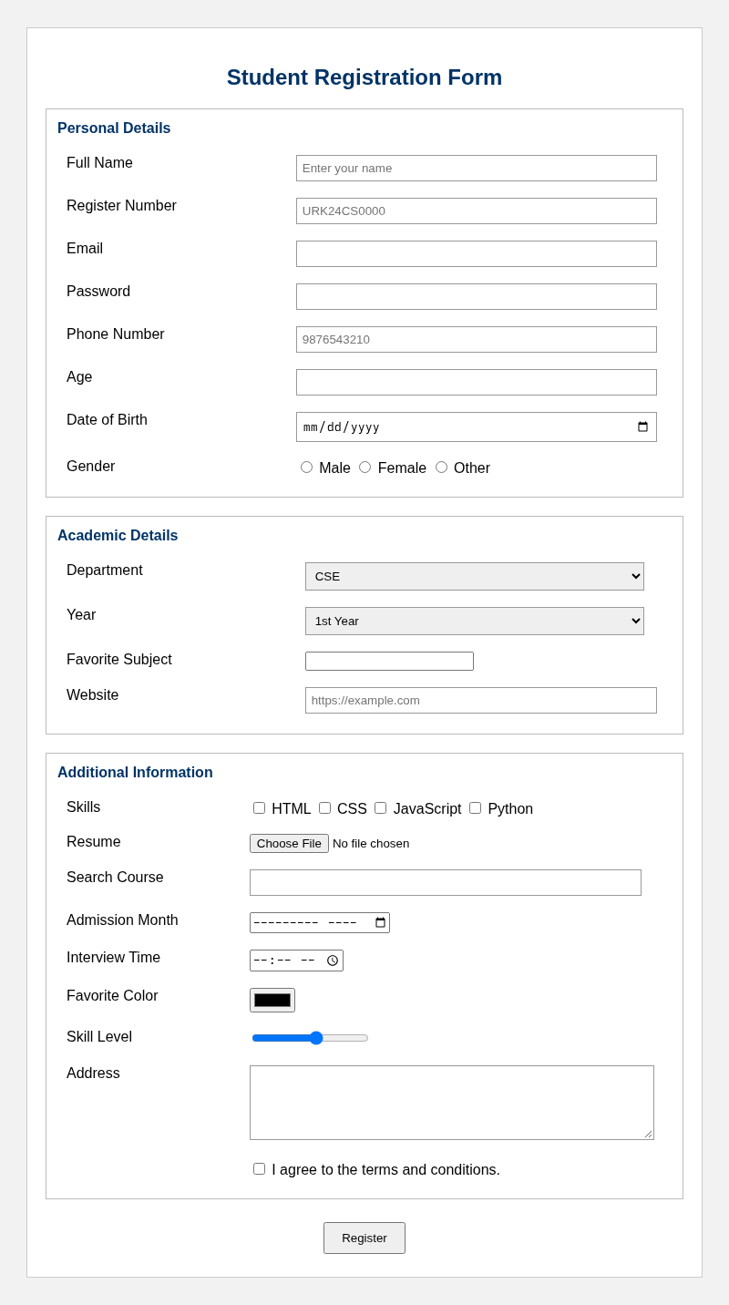
Figure 1: Student Registration Form (empty state)
Registration Form (filled)
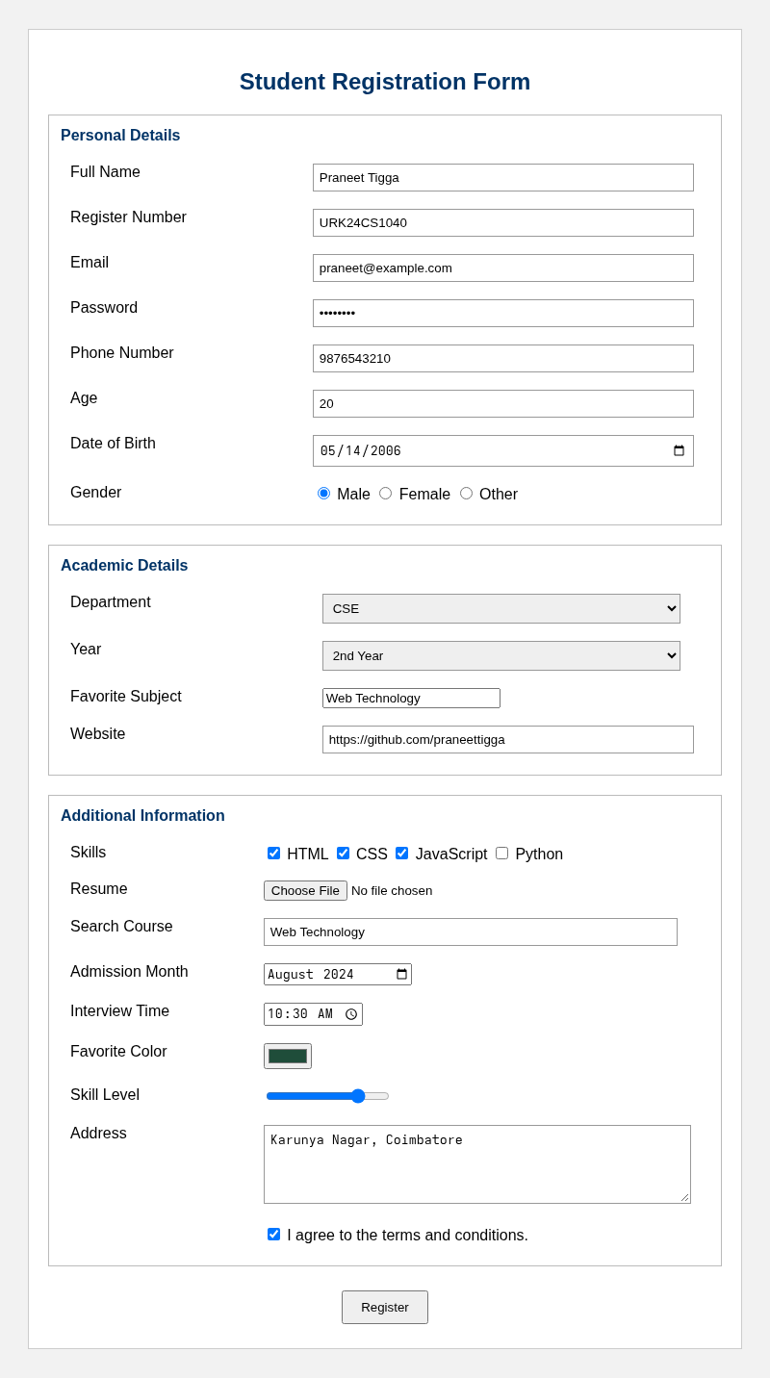
Figure 2: Student Registration Form (filled with sample data)
Result
The Student Registration Form was successfully designed and executed using HTML5 form elements, the various input types, validation attributes and internal CSS. The output matched the expected layout and the form behaved correctly during validation.

